What are the real effects of allowing firms to outsource consumer credit supply?

In September 1958, Bank of America chose Fresno as the site for its introduction of the BankAmericard. The bank issued 60,000 cards to the local population of 250,000 (nearly one per household) and onboarded over 300 merchants.

Fresno city directories, publicly available online from the library of congress, provide a rich data source for studying the evolution of retail businesses over time. These directories include:

-Business names
-Addresses
-Telephone numbers
-Branches of the same business linked across locations
-Advertisements
-Firms linked across years

For example, this entry shows 6 addresses for Karsh’s Bakery.
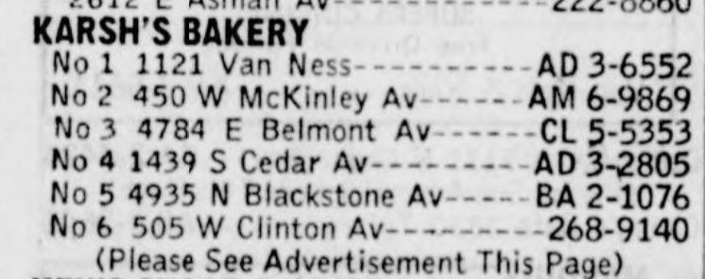

The advertisements are also informative signals of what financing options these businesses offer. For example this advertisement for Broadway Cyclery (with two branches) from 1963 shows that the business accepted BankAmericard:
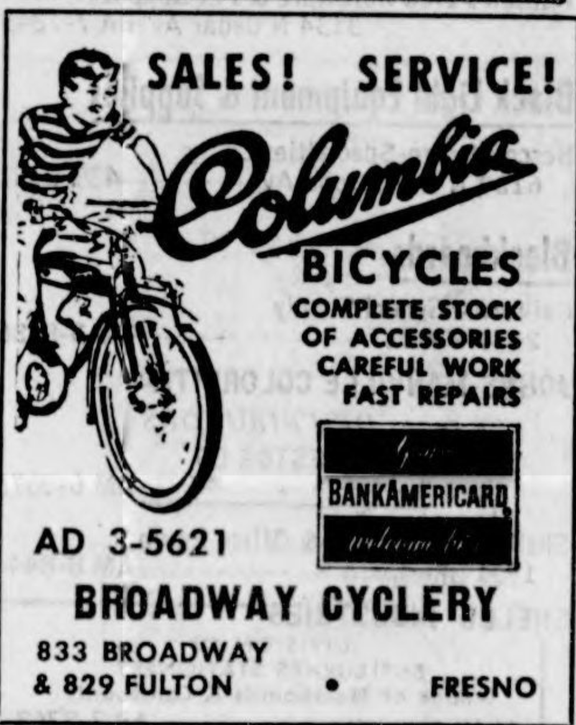

Conversely, Ed Sumner’s Cycle center advertises “Easy Credit Terms”, implying that they offer in-house financing as opposed to the BankAmericard:
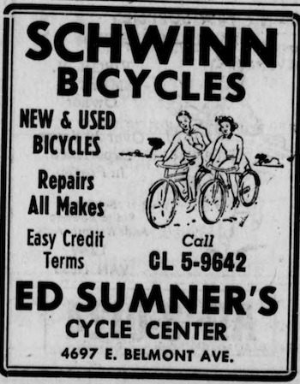

These yellow pages are available for Fresno from the library of Congress for at least 1950-1962, enough coverage for a difference-in-difference analysis. The 1958 volume includes 342 pages. Overall, there are 3,500 city-year volumes available. I have identified the Bicycle retail industry as one which contains significant heterogeneity across firms in credit provision, with some advertising the Bankamericard, some advertising in-house credit terms, and some offering both, such as Ed Sumner’s in 1963:
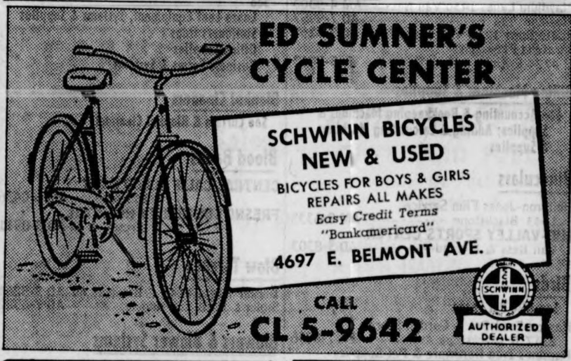

As an exploratory exercise, I examine the yellow pages for Bicycle Retailers 1955-1962 to see how many retailers existed and what financing options they advertised. I consider both Fresno, where the Bankamericard was first introduced in 1958, and Sacramento, a nearby city with similar characteristics in every dimension, but where the Bankamericard was not introduced until 1961. According to historical accounts, the reason why BofA chose Fresno and not Sacramento as the pilot site for the Bankamericard was due to its idiosyncratically high market share in Fresno.

In 1958, the first directory after the Bankamericard introduction, Fresno had 16 bicycle retailers. 7 advertised, and 3 include mention of the following credit options available:

“Layaway Plan” (in-house credit)
“Easy Credit Terms” (in-house credit)
“Merchant Member, Bank of America Charge Account Plan” (accepted Bankamericard).

With information from these directories, it is possible to answer the following kinds of questions:

- Which kinds of businesses (by industry and number of establishments) are most likely to advertise financing? Which are most likely to adopt the Bankamericard?
- Did businesses substitute away from offering credit in favor of the Bankamericard?
- What real outcomes did the Bankamericard change?
  - Business formation and destruction rates?
  - Growth of businesses to multiple addresses?

I have manually collected data from 1955-1962 for Bicycle retailers in Fresno and Sacramento, including the names of the businesses linked across years, number of establishments, whether the firm advertises (or is simply listed), whether the firm advertises in-house financing, and whether the firm advertises the Bankamericard.

Overall, there are 260 listings, or about 17 per city-year. Overall, 45% of firms advertise. Of firms who advertise, 28% advertise in-house financing, and 14% advertise the Bankamericard. 12% of firms enter the sample each year (are “born”), and 8% exit (“die”). Almost all firms (98%) in the bicycle retail industry are single-establishment, although there is one notable case of a firm expanding to a second location the very year that Bankamericard is introduced and was adopted by that firm:
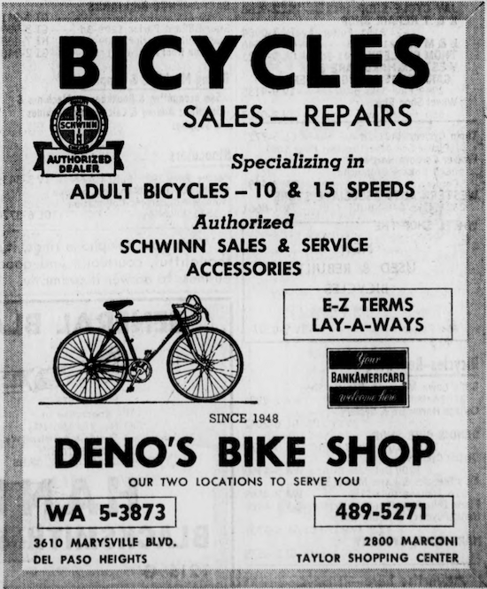

Since there are only 4 multi-establishment firm-years in the sample, I do not attempt to analyze the number of establishments in this pilot analysis.

Staggered introduction of the Bankamericard

As shown by this graph, the bankamericard was first introduced in Fresno in 1958, and in Sacramento in 1961, and was quickly adopted by many firms in this industry. This is the “first stage”. Now I ask – what effects did the introduction of the Bankamericard have on these firms?

Substitution from in-house credit
I can produce the same graph for the fraction of firms advertising in-house financing, and marking the dates, 1958 and 1961 respectively, when the Bankamericard was introduced in Fresno and Sacramento:

If firms adopt the Bankamericard in order to substitute from in-house financing, we would expect these two lines to drop sharply at their corresponding event date. The fact that they do not suggests that something else may be afoot, such as:
- Non-adopting competitors increasing advertisement, or their actual in-house credit supply, in response to the Bankamericard
- In-house financing being a complement, rather than substitute, for the Bankamericard

The size of this pilot sample is too small to draw statistical conclusions thus far – this is a proof-of-concept for what is possible for this data at a larger scale.

Firm birth and death rates
As can be seen from the above graphs, the introduction of the Bankamericard was accompanied by a sharp, temporary increase in the firm birth rate, and a sustained decrease in the firm death rate. This is consistent with external consumer finance allowing more marginal firms to be profitable, and reducing the costs and risks that they face from extending credit themselves.

Relationship to other evidence from market shares
The Consolidated Consumer Analysis data, analyzed separately earlier, shows that large firms with extensive in-house credit card plans such as Sears and Montgomery Ward did not decrease, but rather increased their market shares in Fresno around this time:
This combination of evidence is inconsistent with a story in which external consumer finance helps small firms grow and outcompete large firms. It is instead consistent with a story in which external consumer finance reduces the minimum efficient scale of firms and allows more small businesses to exist even when their market share is small, increasing variety available to consumers.

